apply to Get up to $1000 to attend the wildlife society western section annual conference in yosemite!  Workshop/Professional Development Scholarship Application Presented by the S.F. Bay Area Chapter and Sponsored by | 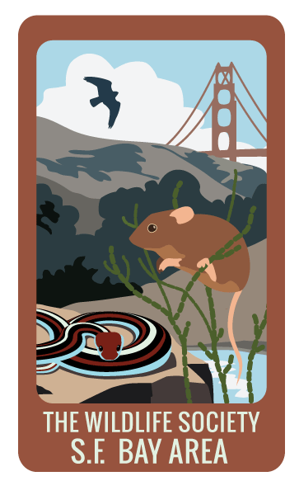

INSTRUCTIONS: To apply for a TWS S.F. Bay Area chapter workshop/professional development scholarship,
please complete the following application in full.

Completed applications should be submitted to Natalie Reeder (ReederN@gmail.com), with the subject line
“Western Section 2019 Conference Application”, on or before December 15th, 2018.

Please include your proof of enrollment/graduation date as attachments, along with the application.
Submissions that are late, or do not follow this format, will not be considered.

To be eligible, applicants must be undergraduate or graduate students willing to show proof of enrollment (scanned student ID); or early career professionals willing to show proof of graduation date (scanned diploma or transcripts). Applicants do not need to be members of the San Francisco Bay Area Chapter at the time of the application, but must be members of the Western Section of The Wildlife Society at the time of registering for the conference, to take advantage of the member’s registration.

Membership can be obtained here: http://tws-west.org/?page_id=101#join or during conference registration.

All applicants will be notified that their application has been received within a week of the submittal date. One applicant will be selected, and notified by December 22nd, 2018.

Event INFORMATION
Event Name |  | The Western Section of The Wildlife Society 2019 Annual Meeting |  |  |  |  |  |  |  |  |  |  |  |  |  |  |  | Event Date |  |  | February 4-8, 2019
Location |  | Tenaya Lodge at Yosemite in Fish Camp, CA |  |  |  |  |  | Reserve rooms at: http://tws-west.org/tenayalodge2019/venue/
Event Fee |  | $225 |  |  |  |  |  | Must complete own registration at  http://tws-west.org/tenayalodge2019/ |  |  |  |  |  |  |  |  |  | TWS will reimburse up to $1,000 for registration, lodging, and travel, based on the applicant’s receipt submittals, at the end of the conference, sponsored by Animex!
Are you receiving additional financial support to attend this event outside of the chapter (i.e. from an employer or TWS Western Section/National)? |  |  |  |  |  |  |  | YES |  | NO |  |  | If so, how much?
 |  |  |  |  |  |  |  |  |  |  |  |  | From whom?

Applicant Information
Last Name |  |  |  |  |  |  | First |  |  |  |  |  |  |  |  |  |  | M.I.
Street Address |  |  |  |  |  |  |  |  |  |  |  |  |  |  | Apartment/Unit #
City |  |  |  |  |  |  | State |  |  |  |  |  |  |  | ZIP
Phone |  |  |  |  |  |  | E-mail Address
Are you currently a member of the SFBA Chapter? |  |  |  |  |  | YES |  | NO | Are you a member of the Western Section? |  |  |  |  |  |  |  |  |  |  | YES |  | NO
Are you currently a member of a student chapter other than the SFBA Chapter? |  |  |  |  |  | YES |  | NO | If so, which?
Have you applied for a SFBA Chapter scholarship in the past? |  |  |  |  |  | YES |  | NO | If yes, were you awarded a scholarship? |  |  |  |  |  |  |  |  |  |  | YES |  | NO
 |  |  |  |  |  |  |  |  | For which event?

Education
Are you currently a college student? |  |  |  | YES | NO |  | If yes, what University are you attending?
 |  |  |  |  |  |  | Graduation Date |  |  |  |  |  |  |  |  | Degree
Are you a recent college graduate (w/in last year)? |  |  |  | YES | NO |  | If yes, what University did you attend?
 |  |  |  |  |  |  | Graduation Date |  |  |  |  |  |  |  |  | Degree
Briefly describe the coursework you are taking/have completed, and how it applies to your professional goals in wildlife biology:

Career Trajectory
Describe your anticipated career trajectory (“What do you want to be when you grow up…”) and how attending this workshop/professional development event will help further your career in wildlife biology:

Elevator Pitch
Briefly describe why you are the best candidate for this scholarship in 100 words or less:

Disclaimer and Signature
I understand that scholarship funding is limited to TWS San Francisco Bay Area chapter-sponsored events (unless otherwise stated) and is awarded at the discretion of the chapter-appointed Review Board, and that funding is based on available chapter funds and may not be available in part, or in full, for every chapter event.
By typing my name and the date below, I certify that my answers are true and complete to the best of my knowledge.
Signature |  | Date

